**User Installation Guide**

**Step 1:** Load the project into Visual Studio 2022 by clicking the **Open a local folder** –

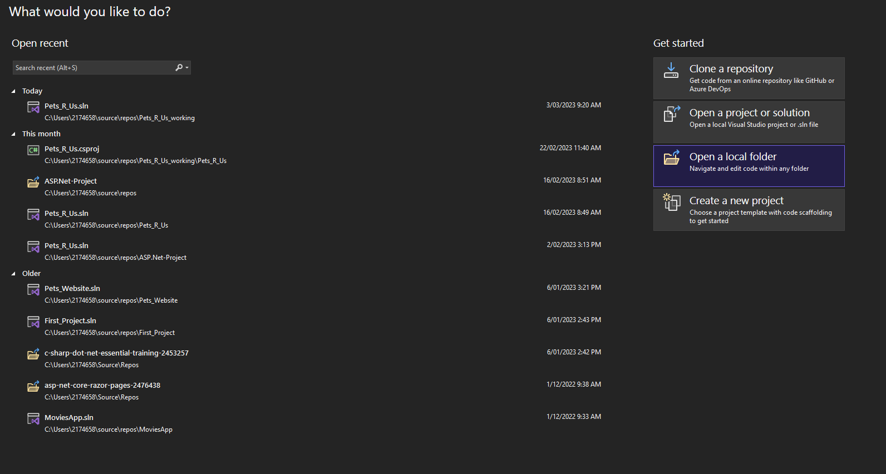

**Step 2:** Click on the project you want to load (e.g. Pets_R_Us)

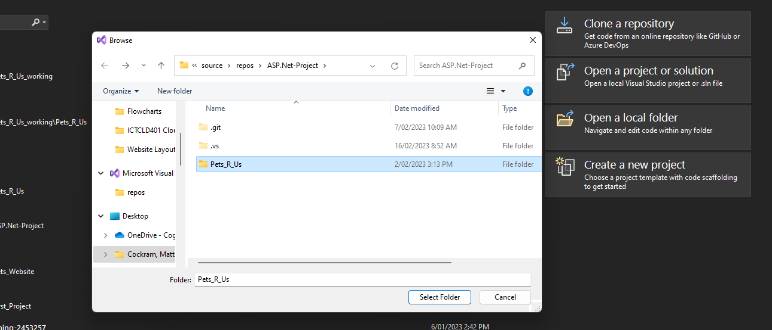

**Step 3:** Load the database migrations on to your machine, go to the **Package Manager Console** (this is in the bottom left corner on our machine but yours may be in a different area)

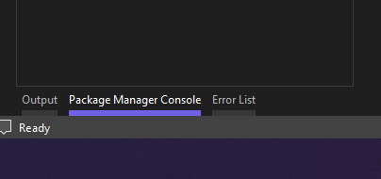

**Step 4:** Once the **Package Manager Console** is open type next to **PM>** “*add-migration*” as shown below and press enter.

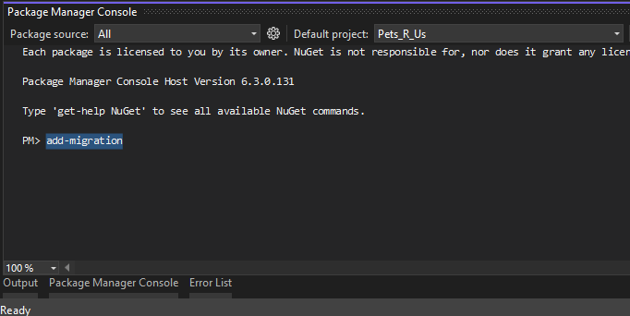

**Step 5:** Name the migration (this can be any name you want), to keep it simple we have named ours AName. Once you have your name press enter.

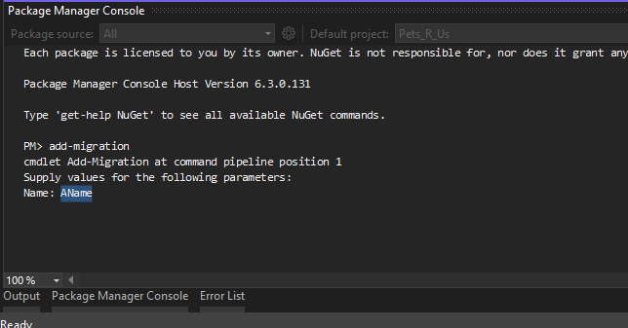

**Step 6:** A page with SQL schemas will be generated like below (yours will be different don’t worry that’s fine)

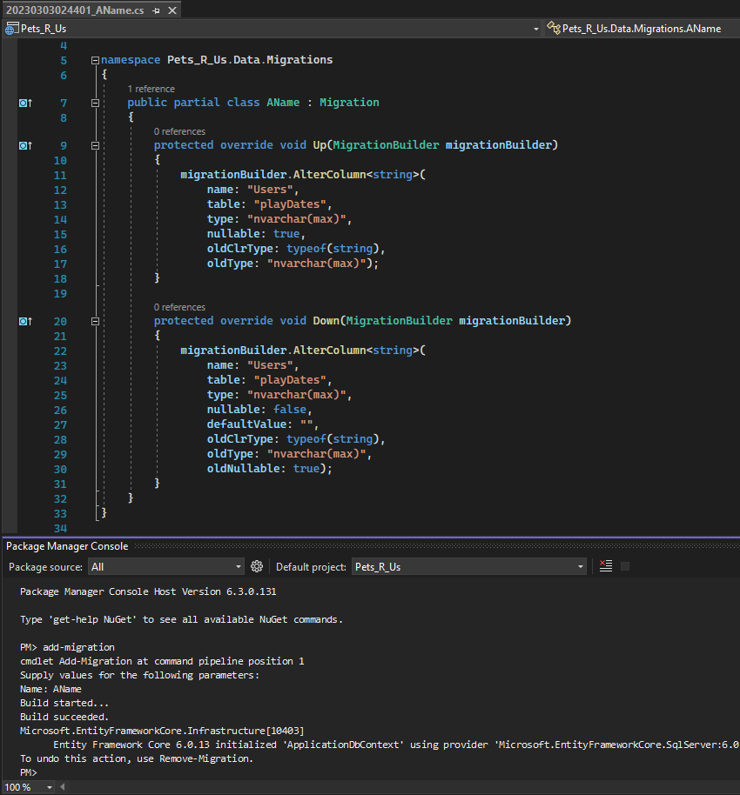

**Step 7:** In the **Package Manager Console** type “*update-database”* this will build the database from the generated schema.

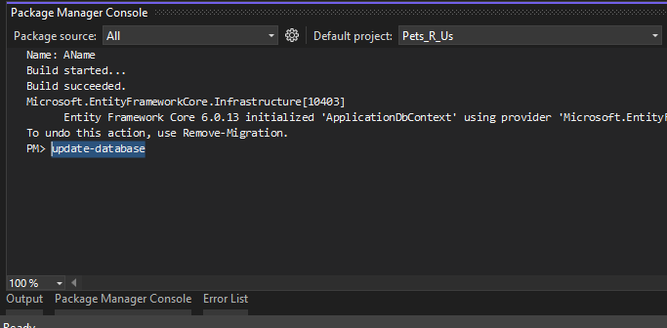

When this is complete the **Package Manager Console** will display **Done** as shown below

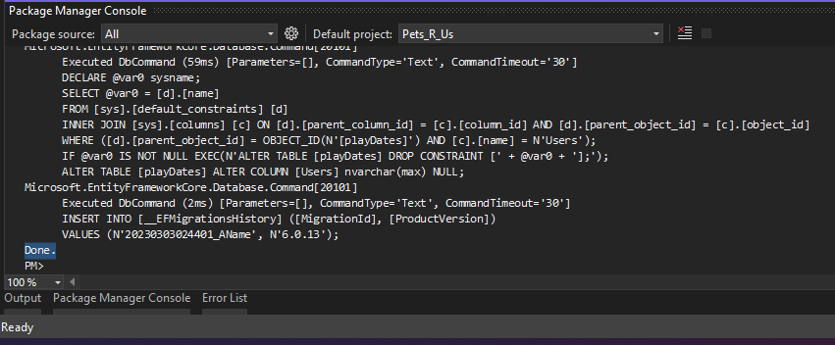

**Step 8:** Once this is completed go to the to the **SQL Server Object Explorer** as shown below. This is on the left hand side of the screen for us, it might be elsewhere for you.

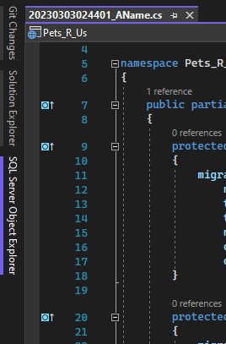

If you can’t see this tab at all go to **View** in the top toolbar and select the **SQL Server Object Explorer** from the menu as shown below.

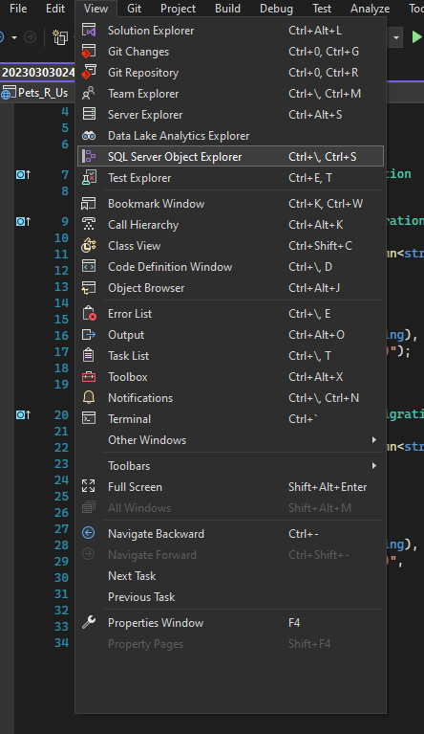

**Step 9:** Once you are in the **SQL Server Object Explorer**  go to the **MSSOLLocalDB > Databases > Pets_R_UsDb > Tables** as shown below

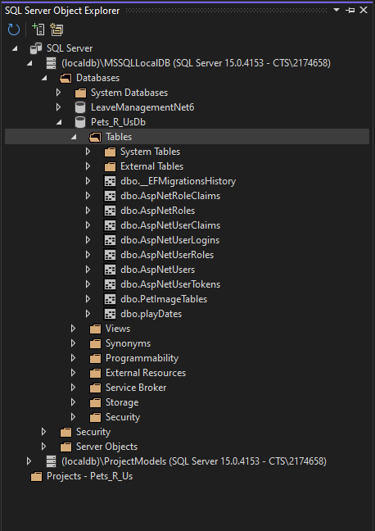

Right click on **dbo.AspNetRoles** and select **View Data** from the list as shown below.

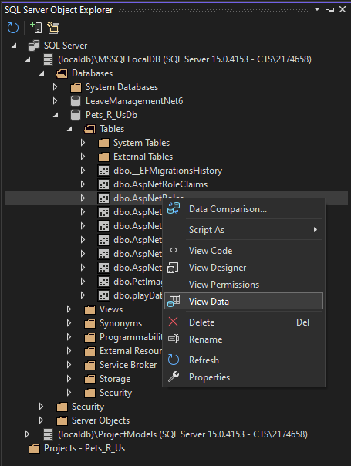

**Step 10:** A blank table will come up, enter the following values exactly as shown below then click one of the null columns below the entered information.

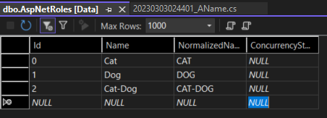

**Step 11:** Press the blue arrow in the top left to update the database.

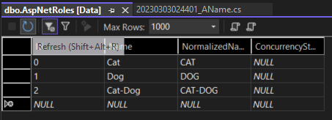

**Step 12:** If the following steps have been done correctly you are now ready to start the application, press the hollow green arrow in the top toolbar of the IDE.

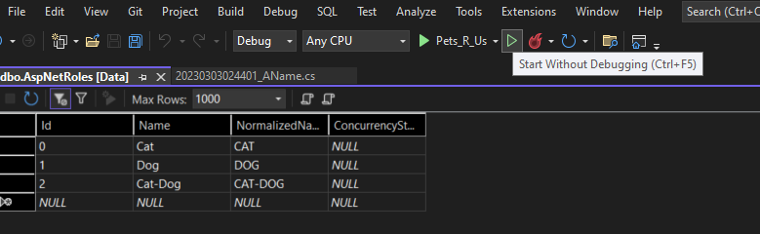

**Step 13:** On first start up this may take a while to open, once the webpage is open go to the three bars in the top right of the screen and click **Register** on the navbar.

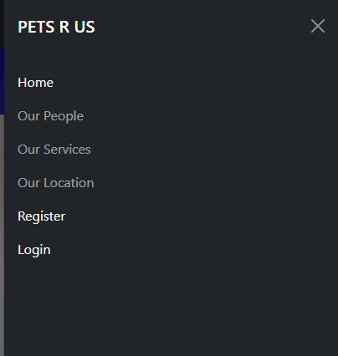

**Step 14:** Fill out all the information on the form, the password must be at least 6 characters and have one number and symbol. Select if you are a cat, dog or both person this will set the background theme for the website. Once this is done hit the register button.

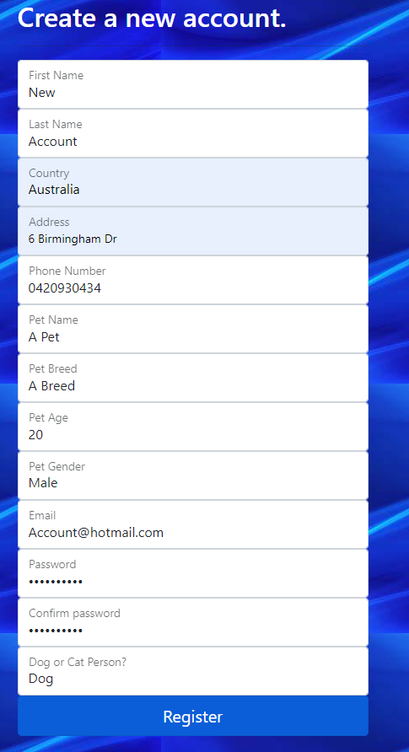

**Step 15:** Click the **Click here to confirm your account.**

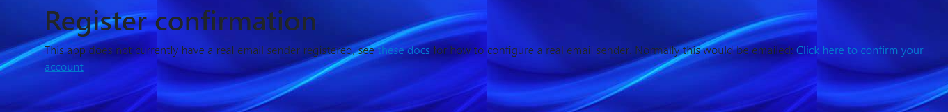

**Step 16:** Click the three bars in the top right of the website and press the **Login** button in the navbar.

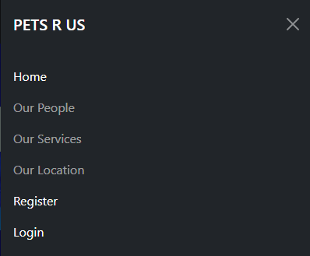

**Step 17:** Enter your details you just entered and press login.

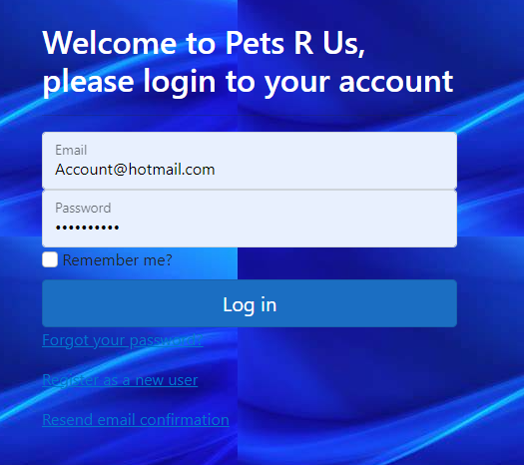

**Step 18:** You now have full access to the website and all functionality, your chosen theme will also be loaded in the background.

